[FOR IMMEDIATE RELEASE
Mary E Emich
Director of Marketing, Sales and Visitor Services
Arizona Aerospace Foundation
6000 East Valencia Rd
Tucson, AZ  85756
Phone (520) 618-4805
memich@pimaair.org 
](mailto:memich@pimaair.org)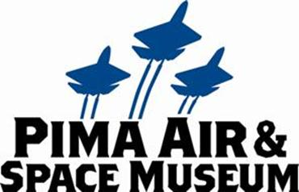

# HOT RODS AND HOT PLANES SIZZLE ON A SEPTEMBER SUNDAY MORNING AT PIMA AIR & SPACE

Tucson—Aug. 26, 2013. Hot rods and hot planes: The Tucson Street Rod Association will display their “rides” at Pima Air & Space on the morning of Sun., Sep. 15, 2013. The Tucson Street Rod Association, the self-proclaimed oldest car enthusiast club in Tucson,­­ organized their September group ride to see the planes at Pima Air & Space Museum and agreed to show off their “souped up” street rods juxtaposed with the museum’s outdoor collection.

Street Rods: As the 1950s rolled into the '60s, teens (and professionals such as Ed “Big Daddy” Roth) customized cars so that they bore little resemblance to assembly-line productions. They became fantastic and futuristic creations, distinctly American including such statements as the addition of the iconic “Rat Fink” character of Ed Roth on the cars. (Rat Fink was a counter culture nod to Mickey Mouse. One story goes that Rat Fink’s appearance on a t-shirt typically yielded a student being expelled from school and thereby enabling that student to work on his customizing his car.) Tom Wolfe, in his 1963 article, "The Kandy-Kolored Tangerine-Flake Streamline Baby,” described the hot rod trend as a communication of “alienation and rebellion that is so important to the teen-age ethos that customizing grew up in.”

“Although the museum prefers to restore our air & space collection with historical accuracy, we believe museum visitors will enjoy these unique museum-worthy vehicles. We are grateful to the Tucson Street Rod Association for sharing with us and the public,” stated Yvonne Morris, Executive Director of the Arizona Aerospace Foundation that operates the Pima Air & Space Museum.

“Although I can’t promise which of our 60+ members’ great rods will be there—member attendance is optional—I can promise what shows will all look really cool next to the planes!” stated Perry Peradotto, event organizer and owner of a 1940 Chrysler New Yorker. He continued, “All of our vehicles are originally pre-1948 models. I can’t wait to photograph mine with the Blue Angel.” Viewing the cars (and photographing them) is included in the price of admissions, that price recently reduced to only $12.25 for Pima County residents. Although visitors are allowed to touch most of the planes at Pima Air & Space, the club respectfully requests the public refrain from touching their cars that will be on display from museum opening (9:00am) until approximately 1:00pm.

Attached:

* PASMDodgeRodTWAMedResRB = 1932 Dodge Sedan driven by Gene DeChant with a Lockheed L-049 Constellation
* PASMRodsTrioB52B36medresRB = 1932 Dodge Sedan and two t-buckets with the Convair B-36J Peacemaker and the Boeing B-52A Stratofortress
* PASMRodsTrioTWAMedResRB = 1932 Dodge Sedan and two t-buckets with a Lockheed L-049 Constellation (John Sipe and Kris Van Horne)
* PASMRodTBuktF18MedRes = t-bucket driven by John Sipe complete with blued exhaust pipes to match the F-18 Hornet painted in the Blue Angel scheme
* PASMRodTBuktHindMedResRB = John Sipe’s t-bucket (note the plate) next to the “new” Mi-24 Hind attack helicopter

**ABOUT PIMA AIR & SPACE MUSEUM**

Be wowed at Pima Air & Space Museum, one of the largest aviation museums in the world and the largest non-government-funded in the U.S. (TripAdvisor ranks it in the Top 10% worldwide for excellent ratings.) Its significant collection, 300 strong from around the globe, covers commercial, military and civil aviation alongside more than 125,000+ artifacts, including a moon rock donated by Tucsonan and Astronaut Frank Borman. Be amazed by many all-time great aircraft: the SR-71 Blackbird (the world’s fastest spy plane); a B-29 Superfortress (the WWII bomber that flew higher, farther and faster plus carried more bombs); the world’s smallest bi-plane; the C-54 (the Berlin Airlift’s star flown by the famous “Candy Bomber”  Col. USAF (Ret.) Gail Halvorsen, a Tucson-area winter resident); plus planes used as renowned-contemporary-artists’ canvases, including Brazilian graffiti artist Nunca. Explore five large hangars totaling more than 177,000 indoor square feet—almost four football fields­—of air/space craft, heroes’ stories and scientific phenomena. Two+ hangars are dedicated to WWII, one each to the European and Pacific theaters. Pima Air & Space maintains its own aircraft restoration center. It also operates exclusive tours of the “Boneyard,” aka the 309th Aerospace Maintenance and Regeneration Group (AMARG) on Davis-Monthan Air Force Base, plus offers a docent-led tram tour of its 80 acres (additional fees apply). Pima Air & Space Museum is located at 6000 E. Valencia Rd., just off I-10 exit 267, in Tucson. More information can be found at [www.pimaair.org](http://www.pimaair.org/), on Facebook, or by calling 520 574-0462.

Note: The 390th Bombardment Group (Heavy) Memorial Museum is closed for reconstruction until further notice.

**ABOUT THE TUCSON STREET ROD ASSOCIATION:**

**The TSRA was formed 42 years ago by a small group of dedicated car enthusiasts who hoped to encourage a local interest in street rods (1948 and older). Little did they know that TSRA would still be in existence forty plus years later. Since those humble beginnings the club has grown to over sixty members and an equal number of cool street rods. More information can be found at** [www.tucsonstreetrodassociation.net](http://www.tucsonstreetrodassociation.net)**.**

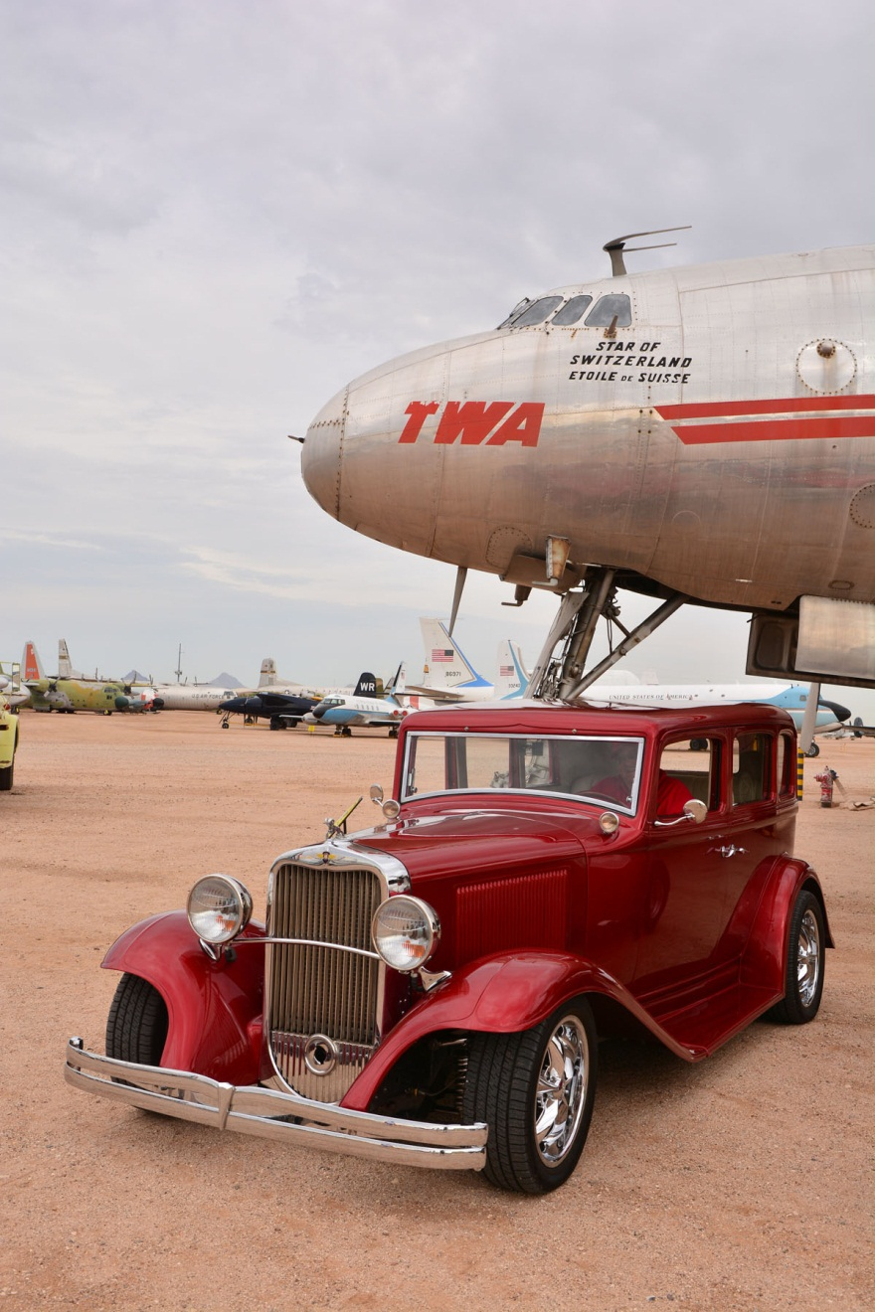

1932 Dodge Sedan driven by Gene DeChant with a Lockheed L-049 Constellation

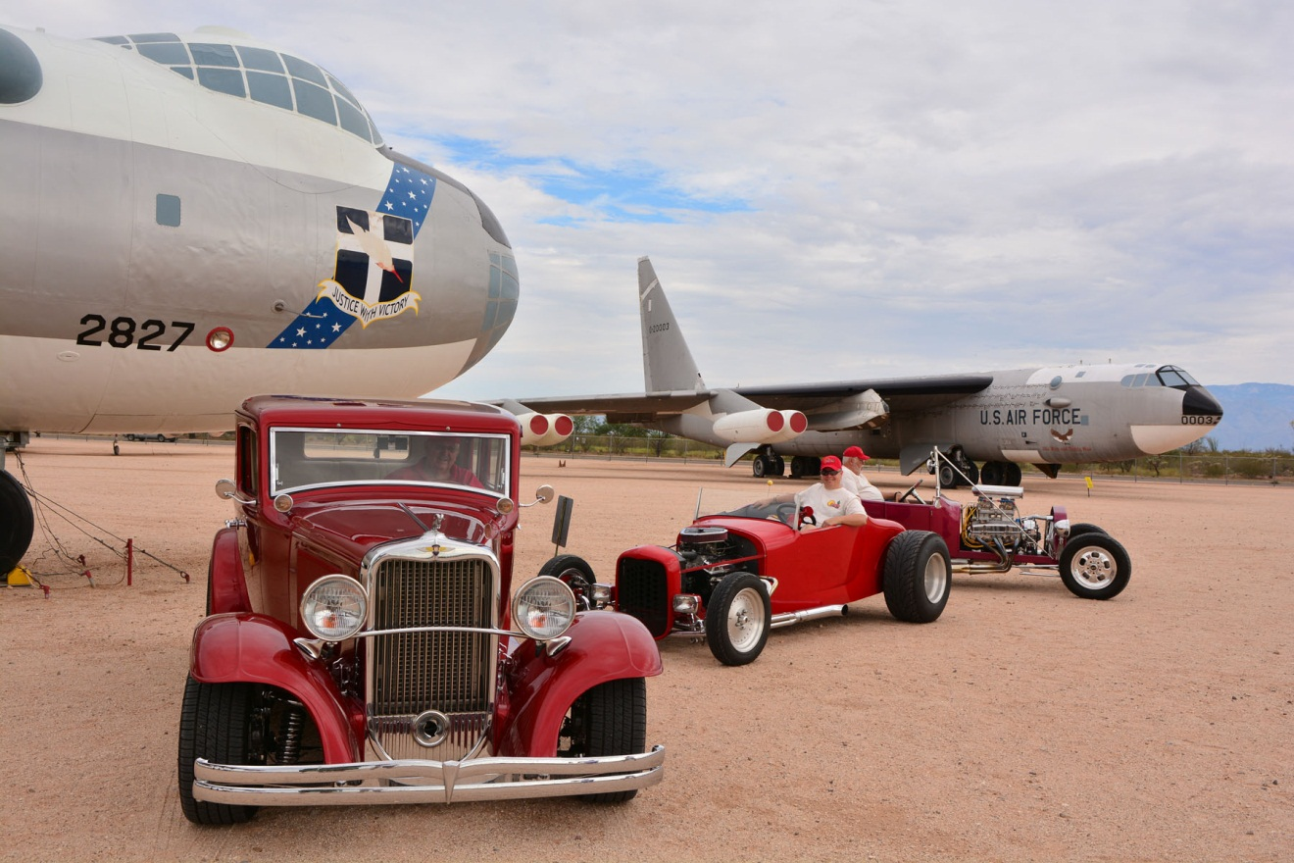

1932 Dodge Sedan and two t-buckets with the Convair B-36J Peacemaker and the Boeing B-52A Stratofortress

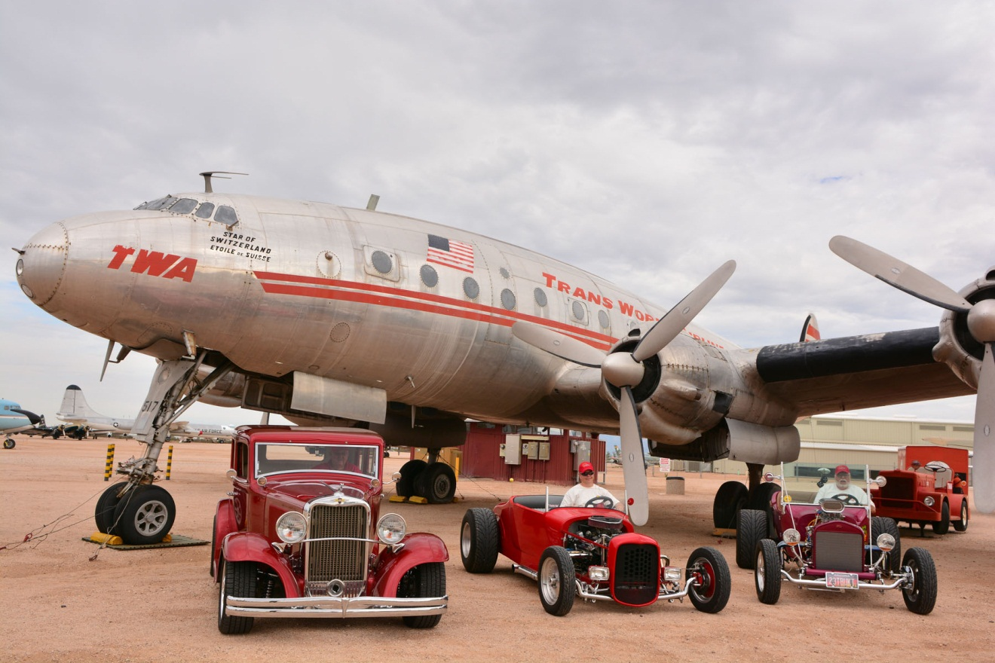

1932 Dodge Sedan and two t-buckets with a Lockheed L-049 Constellation (John Sipe and Kris Van Horne)

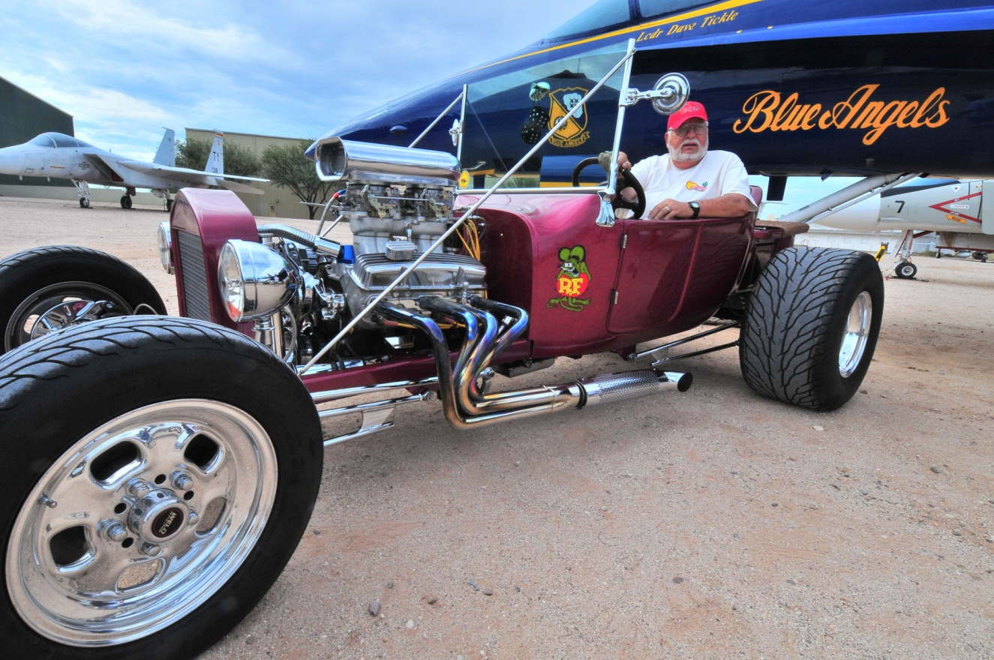

t-bucket driven by John Sipe complete with blued exhaust pipes to match the F-18 Hornet painted in the Blue Angel scheme

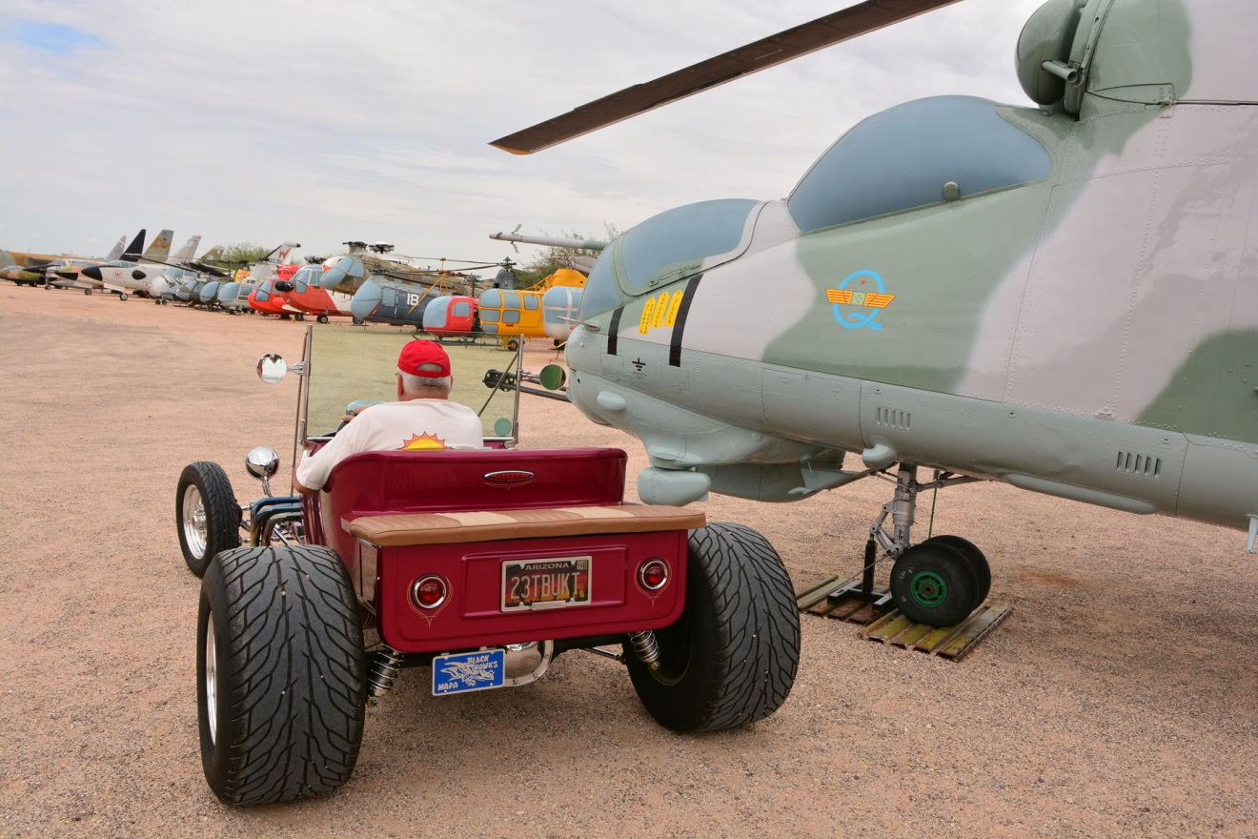

John Sipe’s t-bucket (note the plate) next to the “new” Mi-24 Hind attack helicopter