

**FOR IMMEDIATE RELEASE**

Mary E Emich  
Director of Marketing, Sales and Visitor Services  
Arizona Aerospace Foundation  
6000 East Valencia Rd  
Tucson, AZ 85756  
Phone (520) 618-4805  
[memich@pimaair.org](mailto:memich@pimaair.org)

WORLD-RECORD SEEKING YOUTH AVIATOR CHOSE FLIGHT PATH TO VISIT PIMA AIR & SPACE MUSEUM!

Tucson, AZ–Jul. 12, 2013   19-year-old Australian Aviator Ryan Campbell is choosing his world-record-breaking solo-circumnavigation route with a stopover at Pima Air & Space Museum (on Jul. 15, 2013)! Campbell, who is seeking to break the Guinness World Record for the youngest aviator to fly solo around the world–and to be the first teenager–departed Australia on June 30, 2013, and will arrive at Pima Air & Space Museum on Jul. 15, 2013. According to his spokesman/mother Joanne, “He [Ryan] has chosen Tucson as one of his stops across the USA so that he might get to tour your museum.” Arizona Aerospace Foundation Executive Director Yvonne Morris, who oversees the Pima Air & Space Museum, states, “We are truly complimented that Ryan planned his route to visit us. We frequently hear that Pima Air & Space Museum is the impetus for Tucson-destination vacation plans from all across the globe. We wish Ryan the best of luck in obtaining his goal.” On average, twenty-two percent of visitors to the Pima Air & Space Museum are from foreign countries (Source: Visitor Exit Surveys 2009-present).

Campbell did his homework. As recommended, to maximize his day and assure his seat on the tours offered, Campbell plans to arrive at Pima Air & Space Museum as it opens at 9am on Monday morning.  Campbell also wishes to tour the “Boneyard” aka the 309 **Aerospace Maintenance and Regeneration Group, abbreviated as** AMARG, which can only be toured via the Pima Air & Space Museum Monday through Friday. The 309th AMARG Commander Col. Robert Lepper has asked to meet Campbell while he is on the Davis-Monthan base.

Campbell’s amazing journey can be tracked on Facebook (<https://www.facebook.com/TeenWorldFlight>), Twitter (#‎TeenWorldFlight), his blog (<http://www.teenworldflight.com/blog.html>) and webpage (<http://www.teenworldflight.com/my-achievements.html>).

**ABOUT PIMA AIR & SPACE MUSEUM**

Be wowed like Ryan Campbell at Pima Air & Space Museum, one of the largest aviation museums in the world and the largest non-government-funded in the U.S. (TripAdvisor ranks it in the Top 10% worldwide for excellent ratings.) Its significant collection, 300 strong from around the globe, covers commercial, military and civil aviation alongside more than 125,000+ artifacts, including a moon rock donated by Tucsonan and Astronaut Frank Borman. Be amazed by many all-time great aircraft: the SR-71 Blackbird (the world’s fastest spy plane); a B-29 Superfortress (the WWII bomber that flew higher, farther and faster plus carried more bombs); the world’s smallest bi-plane; the C-54 (the Berlin Airlift’s star flown by the famous “Candy Bomber”  Col. USAF (Ret.) Gail Halvorsen, a Tucson-area winter resident); plus planes used as renowned-contemporary-artists’ canvases, including Brazilian graffiti artist Nunca. Explore five large hangars totaling more than 177,000 indoor square feet—almost four football fields­—of air/space craft, heroes’ stories and scientific phenomena. Two+ hangars are dedicated to WWII, one each to the European and Pacific theaters. Pima Air & Space maintains its own aircraft restoration center. It also operates exclusive tours of the “Boneyard,” aka the 309th Aerospace Maintenance and Regeneration Group (AMARG) on Davis-Monthan Air Force Base, plus offers a docent-led tram tour of its 80 acres (additional fees apply). Pima Air & Space Museum is located at 6000 E. Valencia Rd., just off I-10 exit 267, in Tucson. More information can be found at [www.pimaair.org](http://www.pimaair.org/), on Facebook, or by calling 520 574-0462.

Note: The 390th Bombardment Group (Heavy) Memorial Museum is closed for reconstruction until further notice.

###

Attachments: PASMHangar4.JPG = featuring the B-29 “Superfortress”

PASMSOFGallery.jpg = featuring the SR-71, world’s fastest spy plane

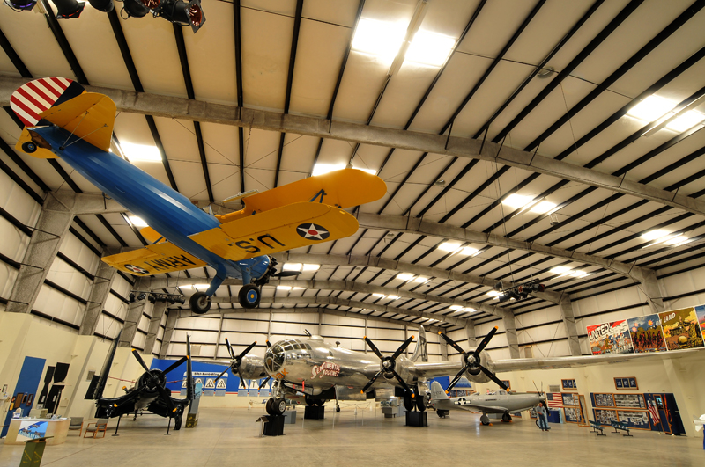

Hangar 4 featuring the B-29 “Superfortress”

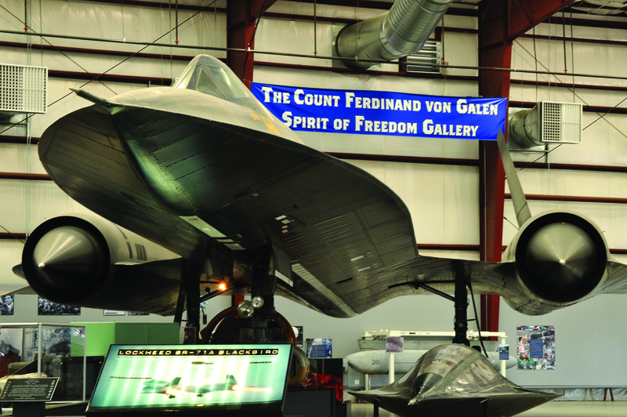

SR-71, the world’s fastest spy plane