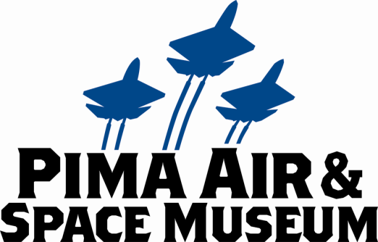

**FOR IMMEDIATE RELEASE**

Mary E Emich  
Director of Marketing, Sales and Visitor Services  
Arizona Aerospace Foundation  
6000 East Valencia Rd  
Tucson, AZ 85756  
Phone (520) 618-4805  
[memich@pimaair.org](mailto:memich@pimaair.org)

PIMA AIR & SPACE MUSEUM ANNOUNCES RADIO-CONTROLLED JETS and LEGO ROBOTICS AS THE SPECIAL FEATURES FOR ITS JULY 27TH “NIGHT WINGS” PROGRAM AND WINNERS OF ITS JUNE COLORING CONTEST

TUCSON—Jul. 12, 2013. The Pima Air & Space Museum announced radio-controlled jets AND Lego Robotics as the special features during its second “Night Wings” summer evening program Sat., Jul. 27th 5 to 9pm. Clay Sherrow, radio-controlled jet enthusiast, will be revving up one of his four planes at 7 and 8pm and displaying 4 of his collection valued at approximately $20,000. “The ‘fire burst’ when the engine starts is fantastic, especially at dusk,” claims Sherrow. The museum’s display area is not conducive for an actual take-off however a radio-controlled flight simulator will be available for everyone to try their hand at controlling a powerful RC jet.

Everyone can also try their hand at the museum’s new Lego Robotics activity too: charting the route and maneuvering a plane, island hopping across the Pacific Ocean. “These robots are amazing!” noted Mina Stafford, Curator of Education at Pima Air & Space Museum, just back from Robotics Camp, “And fun. They are an enthralling addition to our Education and Outreach programs.”

Other kids’ activities include:  a coloring/drawing contest, impact craters, sampling space food (ice cream, YUM!), climbing in the cockpit of the Shooting Star high-speed jet trainer (photo op Mom), plane spotting, and prizes too, including a chance to win a free family membership. These activities are in addition to the museum’s fantastic planes contrasted by the setting sun and inside almost four football fields of hangars. So join us, rain or shine!  Adults only $10. Kids 12 & under are FREE. For only $4 more you can ride the tram and breeze around the 150 planes on the grounds (departure at 6:30 pm).  Great food—burgers, salads, pizza and ice cream—will be available in *The Fight Grill*.

The Winners of the June Night Wings coloring/free-hand drawing contest are: Melanie Shane, age 4; Kyle Valenzuela, age 8; and Gabi Elles, age 11. Each child wins a Crew/family membership to Pima Air & Space and Titan Missile Museum for one year! Creations attached. The August (and final for the summer) Night Wings will be held on Sat., Aug. 24, 2013.

**ABOUT PIMA AIR & SPACE MUSEUM**

Be wowed at Pima Air & Space Museum, one of the largest aviation museums in the world and the largest non-government-funded in the U.S. (TripAdvisor ranks it in the Top 10% worldwide for excellent ratings.) Its significant collection, 300 strong from around the globe, covers commercial, military and civil aviation alongside more than 125,000+ artifacts, including a moon rock donated by Tucsonan and Astronaut Frank Borman. Be amazed by many all-time great aircraft: the SR-71 Blackbird (the world’s fastest spy plane); a B-29 Superfortress (the WWII bomber that flew higher, farther and faster plus carried more bombs); the world’s smallest bi-plane; the C-54 (the Berlin Airlift’s star flown by the famous “Candy Bomber” Col. USAF (Ret.) Gail Halvorsen, a Tucson-area winter resident); plus planes used as renowned-contemporary-artists’ canvases, including Brazilian graffiti artist Nunca. Explore five large hangars totaling more than 177,000 indoor square feet—almost four football fields­—of air/space craft, heroes’ stories and scientific phenomena. Two+ hangars are dedicated to WWII, one each to the European and Pacific theaters. Pima Air & Space maintains its own aircraft restoration center. It also operates exclusive tours of the “Boneyard,” aka the 309th Aerospace Maintenance and Regeneration Group (AMARG) on Davis-Monthan Air Force Base, plus offers a docent-led tram tour of its 80 acres (additional fees apply). Pima Air & Space Museum is located at 6000 E. Valencia Rd., just off I-10 exit 267, in Tucson. More information can be found at [www.pimaair.org](http://www.pimaair.org/), on Facebook, or by calling 520 574-0462.

Note: The 390th Bombardment Group (Heavy) Memorial Museum is closed for reconstruction until further notice.

###

Attachments:

PASMNightWings2013-06-22 19.57.14 = sun setting on Night Wings attendees 2013 (photo by mee)

PASMNightWingsT33LiamLewis = Liam Lewis in the cockpit of the T-33 Shooting Star and getting the thumbs up from Dad (photo by mee)

PASMNightWingsJacobCalebLoos = Jacob & Caleb Loos creating seltzer rockets with community volunteers from Raytheon Missile Systems (photo by mee)

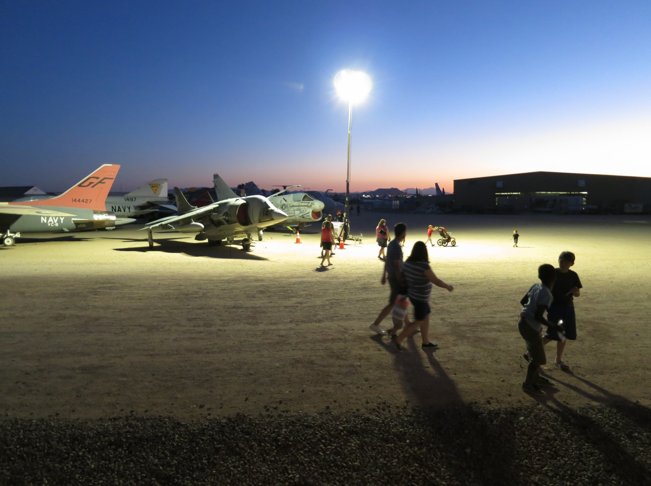

Sun setting on Night Wings attendees 2013

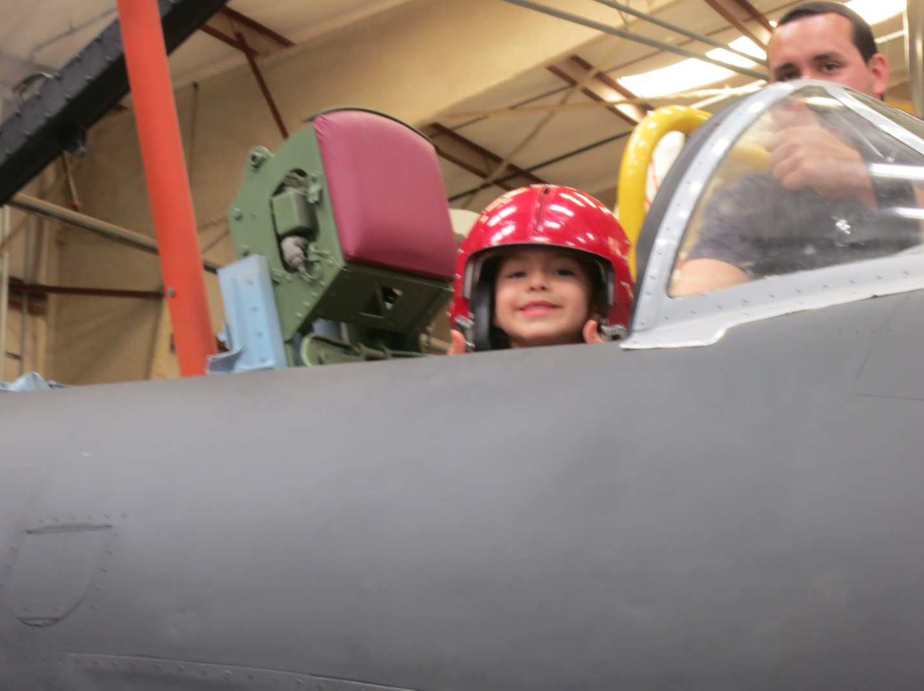

Liam Lewis in the cockpit of the T-33 Shooting Star and getting the thumbs up from Dad

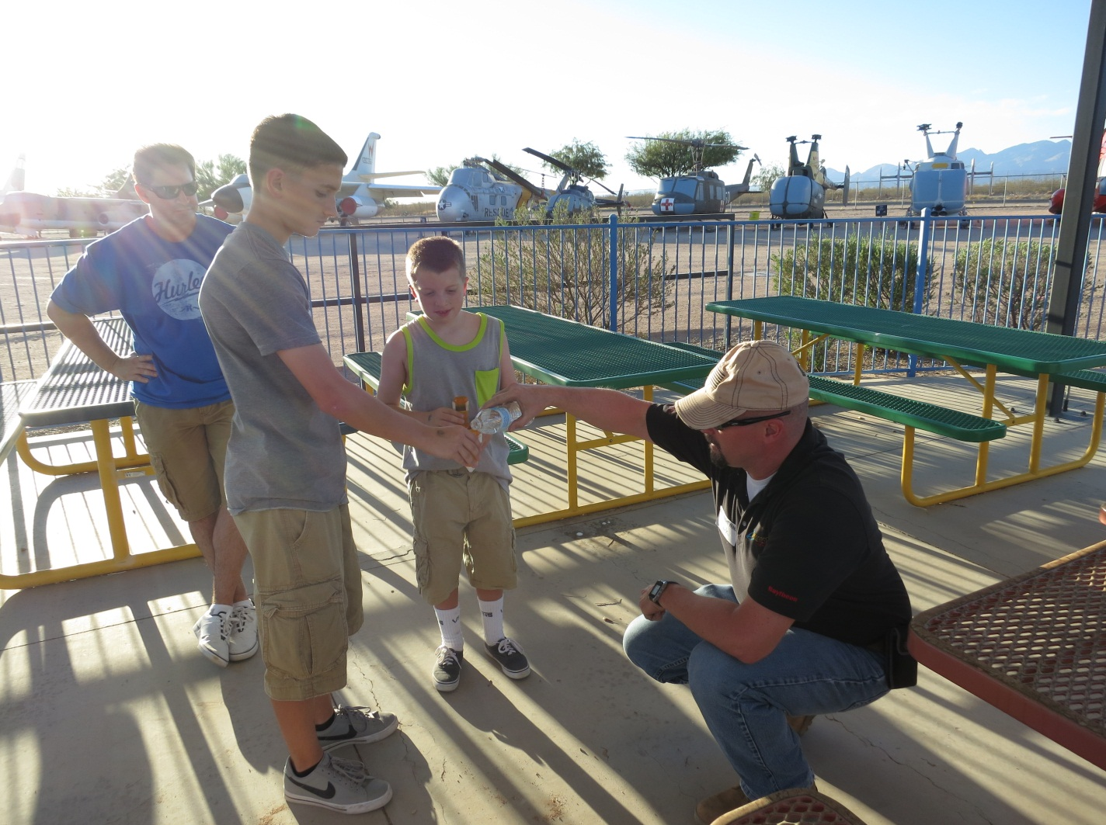

Jacob & Caleb Loos creating seltzer rockets with community volunteers from Raytheon Missile Systems